Copy | Design Sample
2025 ESG Summit: Driving Sustainable Change in Uganda  Join us on World Environment Day, June 5, 2025, at Protea Hotel, Kampala | 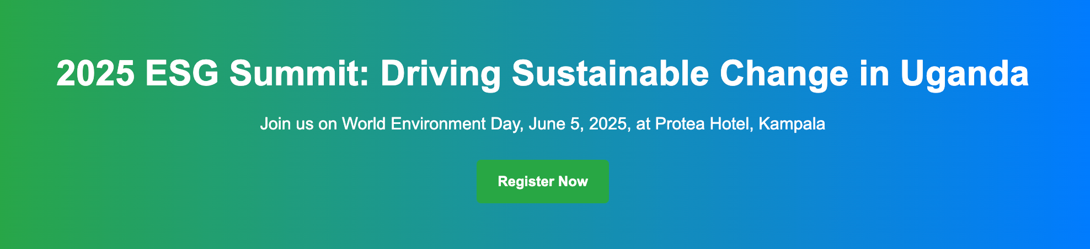
Why Uganda Needs the 2025 ESG Summit  What is the urgent need for ESG in Uganda? Uganda stands at a critical juncture in its development, facing environmental degradation, social inequalities, and governance challenges that demand urgent action. The 2025 ESG Summit, hosted by COG EA Ltd on June 5, 2025, will unite corporate leaders, manufacturers, and professionals to drive better Environmental, Social, and Governance (ESG) practices. By fostering corporate responsibility and building a cadre of ESG-aligned professionals, the Summit will catalyze sustainable change across Uganda.  Key Reasons for the ESG Summit  Addressing Environmental Degradation  Uganda’s ecosystems face threats from deforestation, plastic pollution, and climate change, with 24% of forest cover lost since 1990 (FAO, 2020). Corporate companies and manufacturers will learn sustainable practices, such as waste reduction and renewable energy adoption, to align with SDG 13 (Climate Action) and Uganda’s National Development Plan, ensuring a healthier environment.  Bridging Social Inequalities  Despite economic growth, 41% of Ugandans live below the poverty line (UBOS, 2023), highlighting the need for inclusive corporate policies. The Summit will promote social responsibility, encouraging businesses to invest in community development and equitable employment, aligning with SDG 10 (Reduced Inequalities) and fostering social cohesion.  Strengthening Governance Practices  Weak governance in some Ugandan corporations has led to transparency and accountability gaps. The Summit will equip businesses with ESG reporting standards, such as those from the Global Reporting Initiative, to enhance stakeholder trust and align with SDG 16 (Peace, Justice, and Strong Institutions), driving ethical leadership.  Promoting Corporate Responsibility  Manufacturers and corporations in Uganda will be challenged to take greater responsibility for their environmental and social impacts. Through masterclasses and case studies, the Summit will showcase how ESG integration can improve operational efficiency and brand reputation, aligning with SDG 12 (Responsible Consumption and Production).  Building ESG-Aligned Professionals  To sustain Uganda’s ESG transformation, a growing number of professionals skilled in sustainability is essential. The Summit will offer training and capacity-building sessions, led by experts like The ESG Institute, to empower professionals with ESG expertise, aligning with SDG 4 (Quality Education) and creating a skilled workforce.  Aligned with World Environment Day  Held on June 5, 2025, World Environment Day, the ESG Summit will harness global momentum to address critical environmental issues like plastic pollution and ecosystem restoration. As the world’s largest day for environmental action, engaging 150+ countries, this alignment will position Uganda as a leader in sustainable development, amplifying the Summit’s impact. | 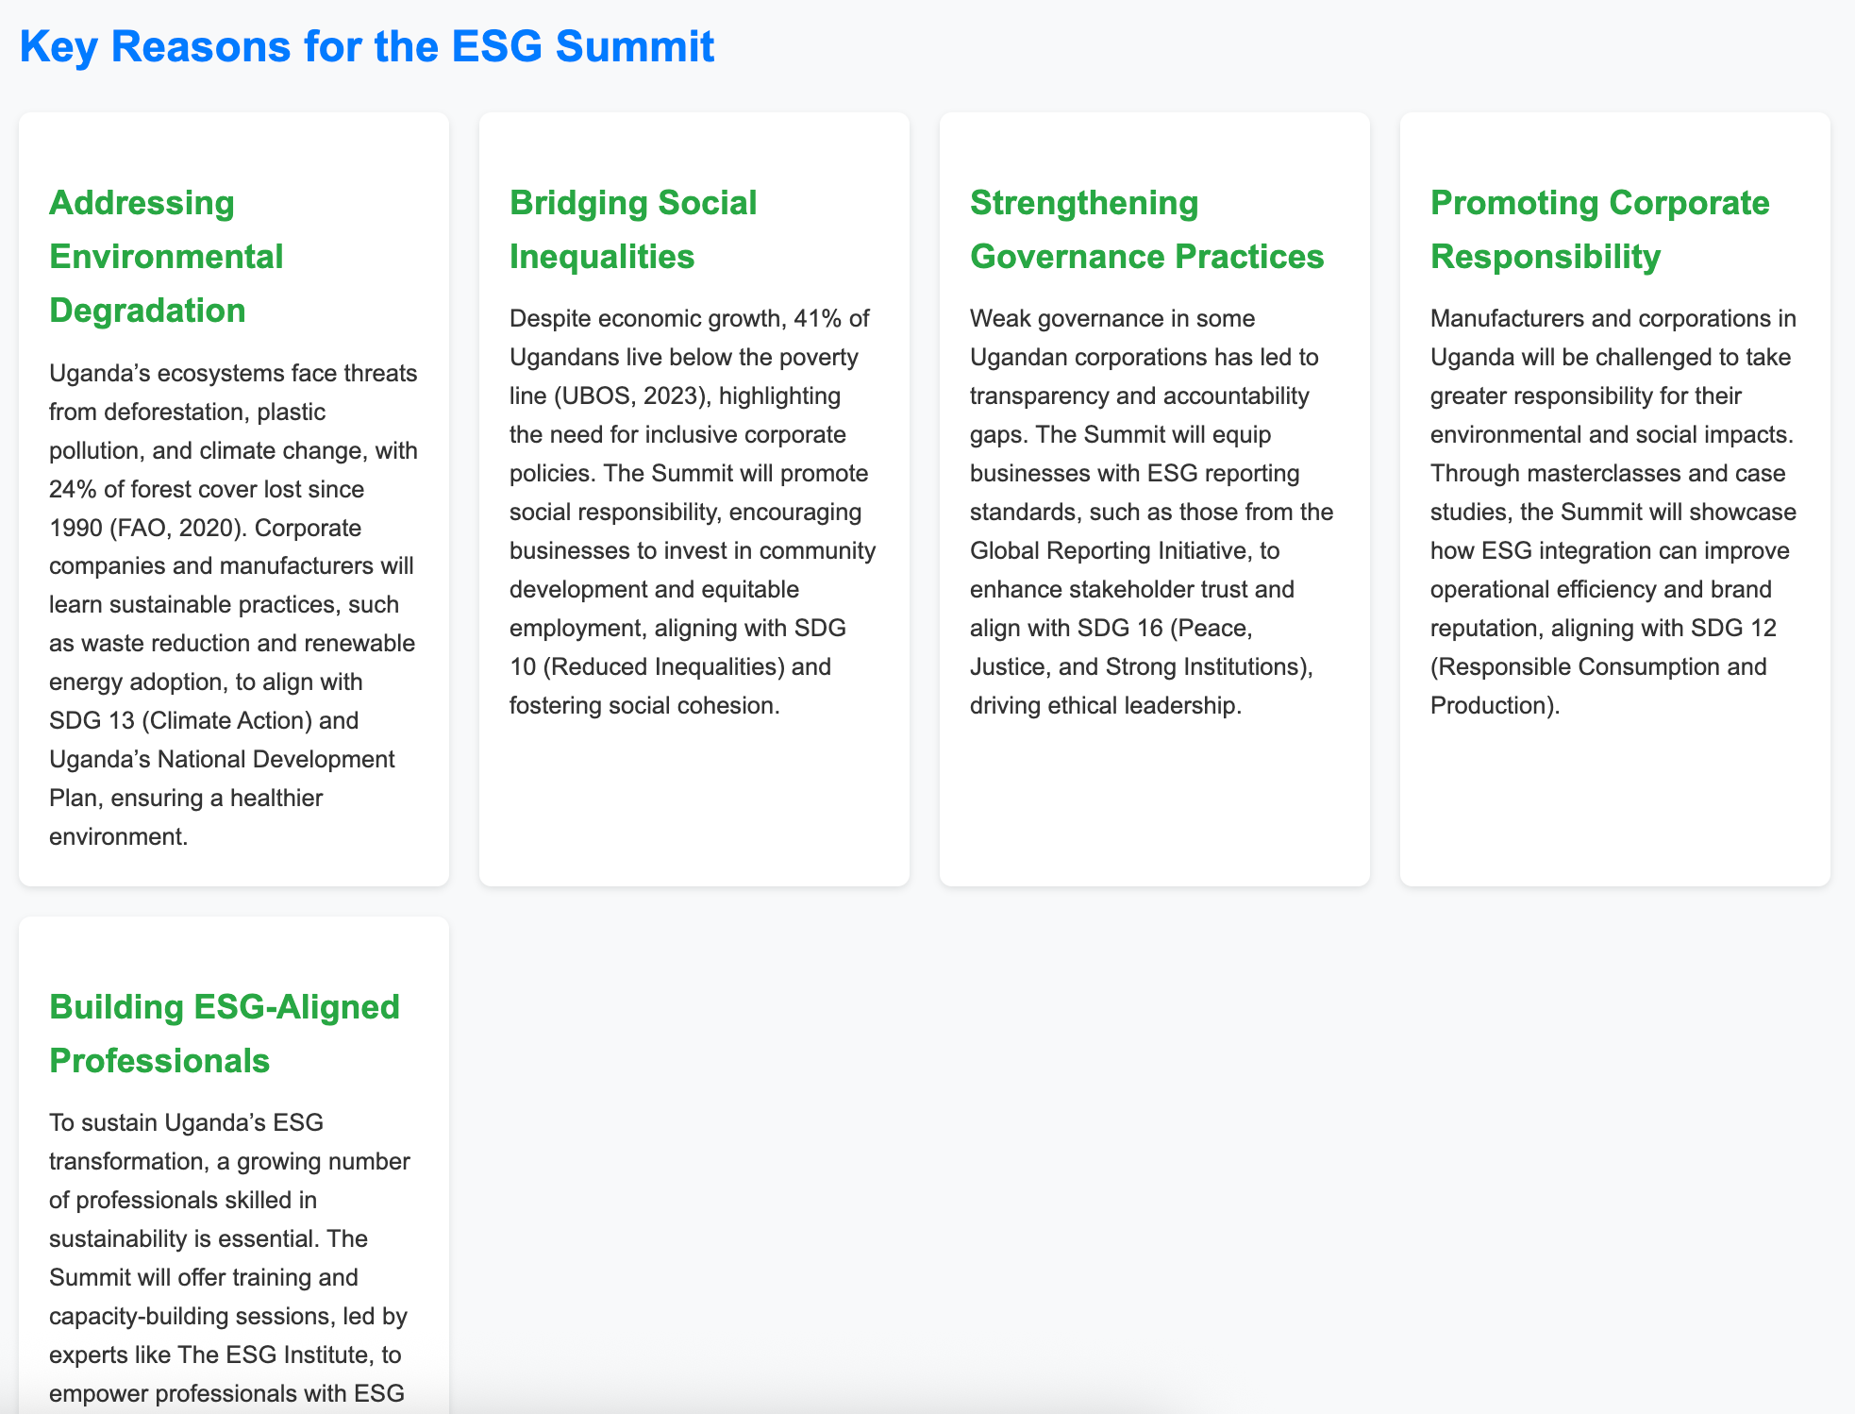
Inspiring Sustainable Change through ESG Best Practices  The 2025 ESG Summit, hosted by COG EA Ltd, is a landmark event uniting corporate leaders, entrepreneurs, NGOs, and sustainability experts to advance Uganda’s sustainable development. Held on World Environment Day, this Summit aligns with global environmental action, focusing on critical issues like plastic pollution and ecosystem restoration.  Expect masterclasses, the launch of Uganda’s 2025 ESG Research Report, and actionable strategies to embed Environmental, Social, and Governance (ESG) principles into your business. Connect, learn, and innovate for a greener, more inclusive Uganda. | 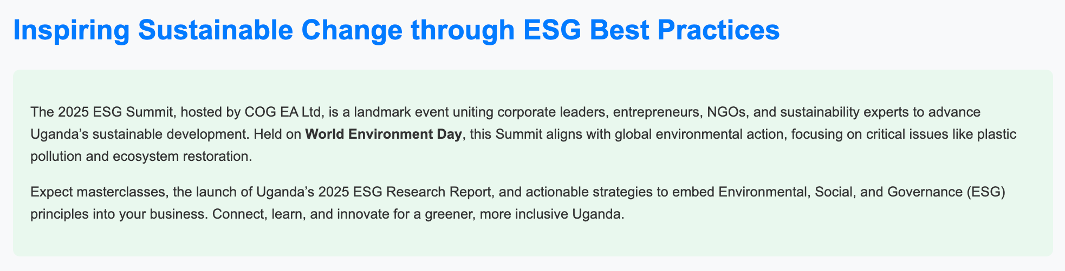
Event Details  When  Thursday, June 5, 2025  8:00 AM – 1:00 PM  Where  Protea Hotel  Acacia Avenue, Kampala, Uganda  Who Should Attend  Corporate Leaders, Board Executives, Business Professionals, Entrepreneurs, MSMEs, NGOs & CSOs  How To Attend  Dial *252*4*2# to buy tickets | 

Program Highlights

Program Schedule

8:00 AM – 8:30 AM: Registration and Networking Breakfast
- Attendees register, collect materials, and network over a light breakfast, setting the stage for a collaborative day.

8:30 AM – 8:45 AM: Opening Remarks by ESG Convener (COG EA Ltd)
- Speaker: Paul Mwirigi Muriungi, COG EA Ltd - ESG Convener: Welcome address outlining the Summit’s objectives, Uganda’s ESG landscape, and COG EA Ltd.’s commitment to fostering sustainable practices. Emphasis on aligning ESG with Uganda’s National Development Plan and SDGs, highlighting the importance of collective action for sustainable change.

Partner Bites: 8:45 AM – 9.45 AM

- Partner: Tree Adoption Uganda
- Title: Reforestation as an ESG Cornerstone: Lessons from Uganda

- Partner: Nickson Mugalula, Manager Mobicast Media
- Title: Leveraging Digital Innovation for ESG Impact & Carbon Footprint Reduction

- Partner: District Governor or ESG Committee Chair, Rotaract Uganda
- Title: Community-Driven ESG: Rotaract’s Role in Driving Forward Sustainable Development & The ESG Agenda

- Partner: John Ernest Ssekisonge. Managing Director, Kasi Insights
- Title: Unveiling Uganda’s 2025 ESG Research Report: Measuring Impact & Insights for Sustainable Progress

- Partner: Samuel Hooper, Head of Marketing - Hariss International Limited
- Title: Sustainable Manufacturing: How Manafacturers Can Limit Plastic Waste

- Partner: Charity Winnie Kamusiime Asiimwe: President, Uganda Marketers Society
- Title: Brand Marketing for Good: Embedding ESG in Brand Marketing & Campaign Strategies

- Partner: Irene Nakasiita: President, Public Relations Association of Uganda (PRAU)
- Title: Communicating ESG by Building Trust through Transparent PR, Reputation & Trust

9:45 AM – 11:00 AM: ESG Masterclass 1 – ESG, SUSTAINABILITY, OPERATIONS & REPORTING: Global Reporting Initiative (GRI)
- Facilitator: Douglas Kativu, Director, GRI Africa
- Title: Transforming Business through Sustainability Reporting: GRI Standards in Action
  - Overview of GRI’s globally recognized standards for ESG reporting, their role in enhancing transparency, and practical steps for Ugandan businesses to adopt them.
  - Includes case studies on improved stakeholder trust and financial performance.
  - Provide a strategic framework for ESG reporting, emphasizing its relevance to Uganda’s private sector.
  - Share GRI’s work on the ‘Africa Shared Value’ and how their reporting framework is a framework for Africa ESG Reporting and Measurement.

11:00 AM – 12:00 NOON: ESG Masterclass 2 – TRAINING & CAPACITY BUILDING: The ESG Institute
- Facilitator: Mrs. Sabrina Shadie, Senior Sustainability Advisor, The ESG Institute
- Title:The Power Of Training & Capacity Building In Overcoming The ESG Compliance Hurdle
  - The ESG Institute - A game-changer for companies
  - How to elevate your ESG performance and set yourself apart from the competition through ESG & Sustainability Training & ESG Business Advisory Services
  - Diploma in ESG Strategy: How having the right skills can set you apart in the fast-growing sustainability market and help you stay ahead of the curve!

12:00 PM – 01:00 PM:
- Joint Panel Q & A Session
- Closing Remarks and Call to Action
- Issuance of certificates
- Group photo
- Networking and cocktails to follow

Featured Speakers:

- Partner: Tree Adoption Uganda
- Title: Reforestation as an ESG Cornerstone: Lessons from Uganda

- Partner: Nickson Mugalula, Manager Mobicast Media
- Title: Leveraging Digital Innovation for ESG Impact & Carbon Footprint Reduction

- Partner: District Governor or ESG Committee Chair, Rotaract Uganda
- Title: Community-Driven ESG: Rotaract’s Role in Driving Forward Sustainable Development & The ESG Agenda

- Partner: John Ernest Ssekisonge. Managing Director, Kasi Insights
- Title: Unveiling Uganda’s 2025 ESG Research Report: Measuring Impact & Insights for Sustainable Progress

- Partner: Samuel Hooper, Head of Marketing - Hariss International Limited
- Title: Sustainable Manufacturing: How Manafacturers Can Limit Plastic Waste

- Partner: Charity Winnie Kamusiime Asiimwe: President, Uganda Marketers Society
- Title: Brand Marketing for Good: Embedding ESG in Brand Marketing & Campaign Strategies

- Partner: Irene Nakasiita: President, Public Relations Association of Uganda (PRAU)
- Title: Communicating ESG by Building Trust through Transparent PR, Reputation & Trust

Meet Our Strategic Partners of the 2025 ESG Summit Who Are Driving Sustainable Change  The 2025 ESG Summit, hosted by COG EA Ltd, will unite visionary Strategic Partners to advance Environmental, Social, and Governance (ESG) principles in Uganda.  These partners will align with Uganda’s National Development Plan, the Sustainable Development Goals (SDGs), and the global momentum of World Environment Day to inspire sustainable transformation.  Tree Adoption Uganda  Tree Adoption Uganda will champion reforestation, aligning with SDG 15 (Life on Land) and Uganda’s environmental goals. Their tree-planting initiatives across Kampala, Mbale, Mbarara, and Gulu will engage communities to combat deforestation and restore ecosystems. At the Summit, they will highlight reforestation as a cornerstone of ESG’s environmental pillar, driving sustainable impact.  Mobicast Media  Mobicast Media will leverage digital innovation to reduce carbon footprints, supporting SDG 9 (Industry, Innovation, and Infrastructure). Their sustainable communication strategies will amplify ESG impact across Uganda. At the Summit, they will showcase digital solutions for environmental challenges, advancing Uganda’s sustainability agenda.  Rotaract Uganda  Rotaract Uganda will drive community-led ESG initiatives, aligning with SDG 11 (Sustainable Cities and Communities). Their grassroots projects have promoted social inclusion and environmental stewardship. At the Summit, they will emphasize community-driven sustainability, inspiring local action.  Kasi Insights  Kasi Insights will deliver data-driven ESG insights, supporting SDG 17 (Partnerships for the Goals). Their 2025 ESG Research Report, to be launched at the Summit, will provide actionable strategies for Uganda’s sustainable growth. Their work will foster evidence-based decision-making for businesses and policymakers.  Hariss International Limited  Hariss International will advance sustainable manufacturing, aligning with SDG 12 (Responsible Consumption and Production). Their efforts to reduce plastic waste will strengthen Uganda’s environmental goals. At the Summit, they will showcase eco-friendly practices, leading by example.  Uganda Marketers Society  The Uganda Marketers Society will embed ESG in brand marketing, supporting SDG 8 (Decent Work and Economic Growth). Their efforts to ensure campaigns will promote sustainable practices among marketing professionals. At the Summit, they will highlight marketing strategies for sustainability, driving industry change.  Public Relations Association of Uganda (PRAU)  PRAU will foster transparent PR, aligning with SDG 16 (Peace, Justice, and Strong Institutions). At the Summit, they will emphasize credible ESG communication, enhancing public trust in sustainability efforts.  Global Reporting Initiative (GRI)  GRI will provide globally recognized ESG reporting standards, aligning with SDG 12 (Responsible Consumption and Production). Their masterclass at the Summit will equip Ugandan businesses with tools for transparency and stakeholder trust, fostering accountability in sustainability practices.  The ESG Institute  The ESG Institute will drive ESG training and capacity building, supporting SDG 4 (Quality Education). Their Summit masterclass will empower businesses with compliance and performance skills, equipping professionals to lead Uganda’s sustainability transformation.  Join Us & The ESG Movement  The 2025 ESG Summit will be a pivotal moment for Uganda’s sustainable future. Corporate leaders, manufacturers, and professionals will come together to drive meaningful change through better ESG practices. Register now and be part of this transformative event and help shape a greener, more inclusive, sustainability movement in Uganda. Secure your spot at the 2025 ESG Summit and contribute to a greener, more inclusive future.  Contact Us  Have questions or want to partner? Reach out to COG EA Ltd.  Email: info@cog-ea-ltd.com  Phone: +256 776 888 750 | 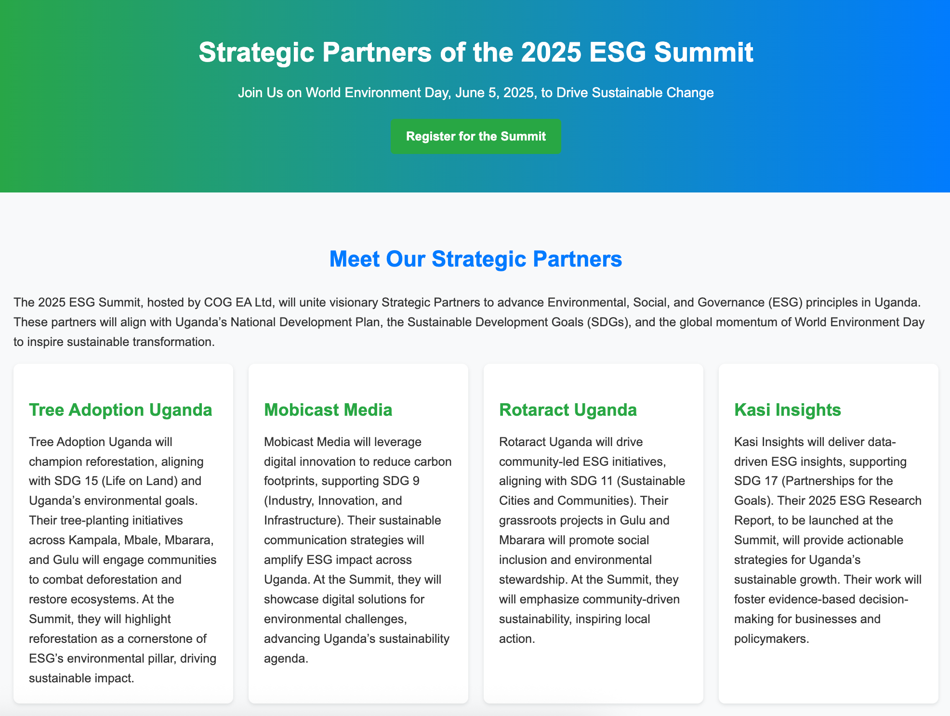  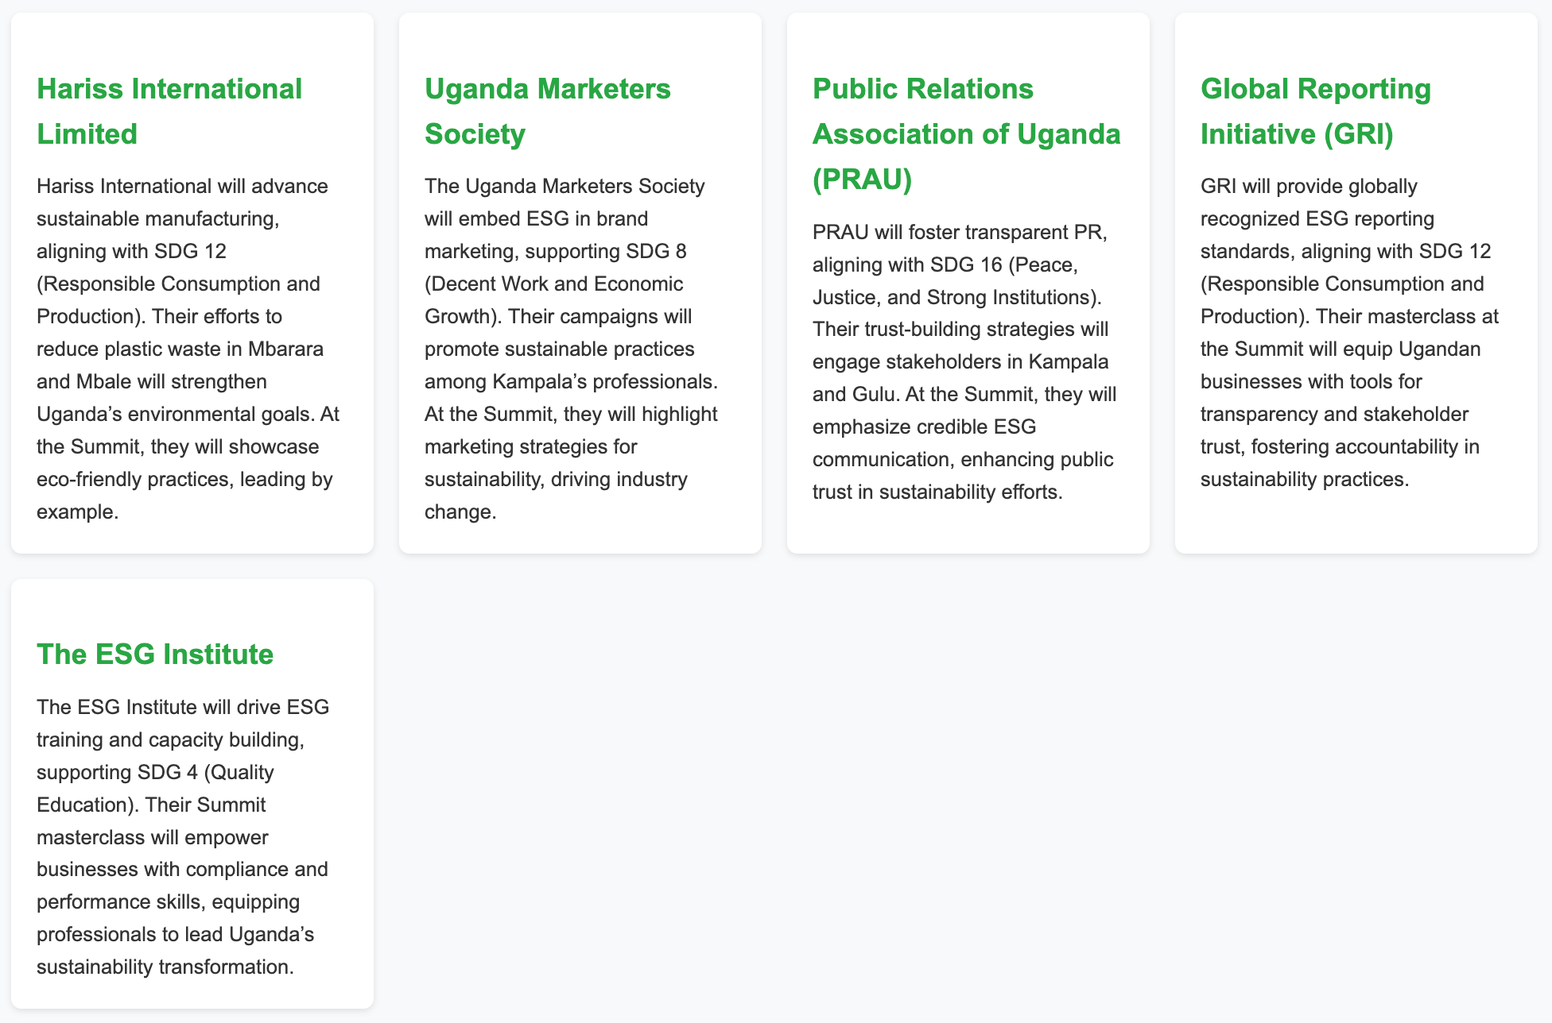

COG EA Ltd: Your Trusted ESG Partner
Leading ESG Compliance, Reporting, and Sustainability Communication for the 2025 ESG Summit
Partner with Us

Why Choose COG EA Ltd for ESG Excellence?
As the convener of the 2025 ESG Summit on World Environment Day, June 5, 2025, COG EA Ltd will bring nearly a decade of expertise in public relations, marketing communications, digital, and creative services to empower businesses in Uganda, Kenya, Nigeria, and Zambia. With a proven track record of driving impactful campaigns, COG EA Ltd will be your ideal partner for ESG compliance, sustainability reporting, and effective communication, empowering your organization to thrive in a sustainable future. Contact us today to start your ESG journey.

Since its inception, COG EA Ltd has delivered transformative campaigns across East and Southern Africa. As part of the Capital One Group ecosystem, we draw on a rich heritage of innovative marketing communications, recognized for excellence in creative strategy and client service. Our work spans major brands and sectors, delivering measurable results in public relations, digital engagement, and creative storytelling. At the 2025 ESG Summit, COG EA Ltd will showcase this expertise, uniting industry leaders to advance Uganda’s sustainable future.

Our ESG Expertise

ESG Compliance
COG EA Ltd will guide businesses through complex ESG regulations, ensuring adherence to international standards like the IFC Performance Standards and local frameworks. Our strategic advisory services will help companies navigate compliance challenges, enhancing resilience and stakeholder trust.

Sustainability Reporting
Leveraging partnerships with global leaders like the Global Reporting Initiative, COG EA Ltd will craft transparent, data-driven sustainability reports that meet stakeholder expectations. Our expertise will ensure reports align with SDG 12 (Responsible Consumption and Production) and boost corporate credibility.

Sustainability Communication
With nearly 10 years of experience in public relations and digital storytelling, COG EA Ltd will create compelling narratives to communicate your ESG commitments. Our campaigns will engage diverse audiences across Uganda, Kenya, Nigeria, and Zambia, fostering trust and brand loyalty.

Capacity Building
COG EA Ltd will empower professionals through ESG training and workshops, building a skilled workforce aligned with SDG 4 (Quality Education). Our Summit masterclasses will equip businesses with tools to integrate ESG into operations, driving long-term impact.

